**Docker Setup and Deployment Output**

**Praveen Murukan-20005276**

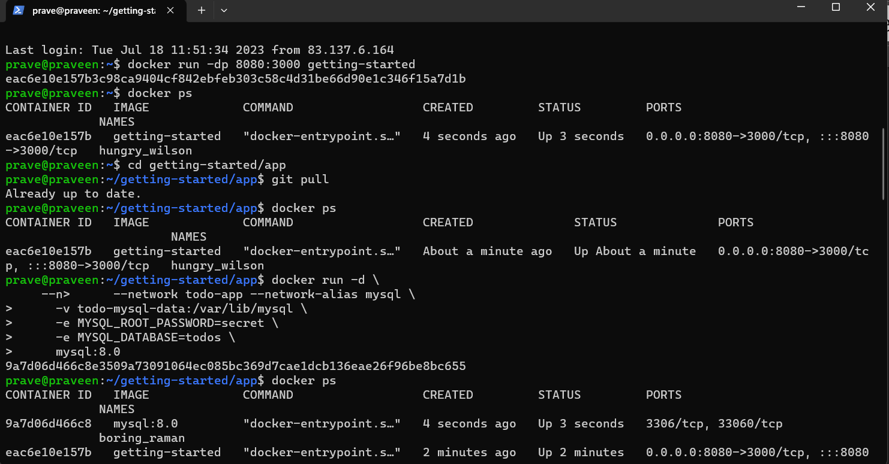

**Figure 1: Rebuilding the image**

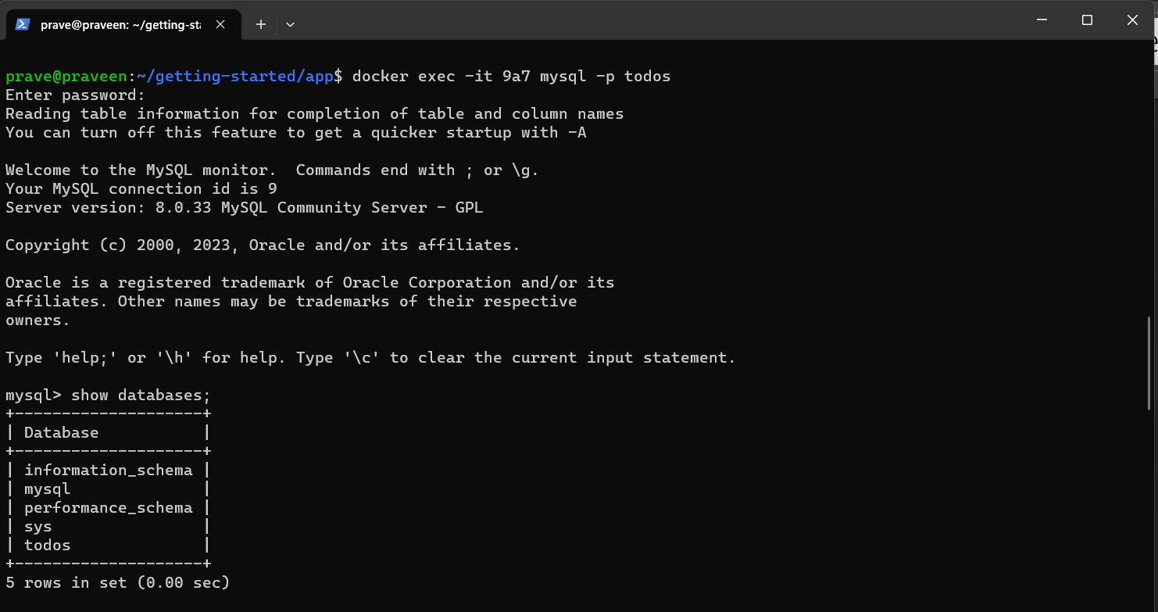

**Figure 2 : executing the MySQL container**

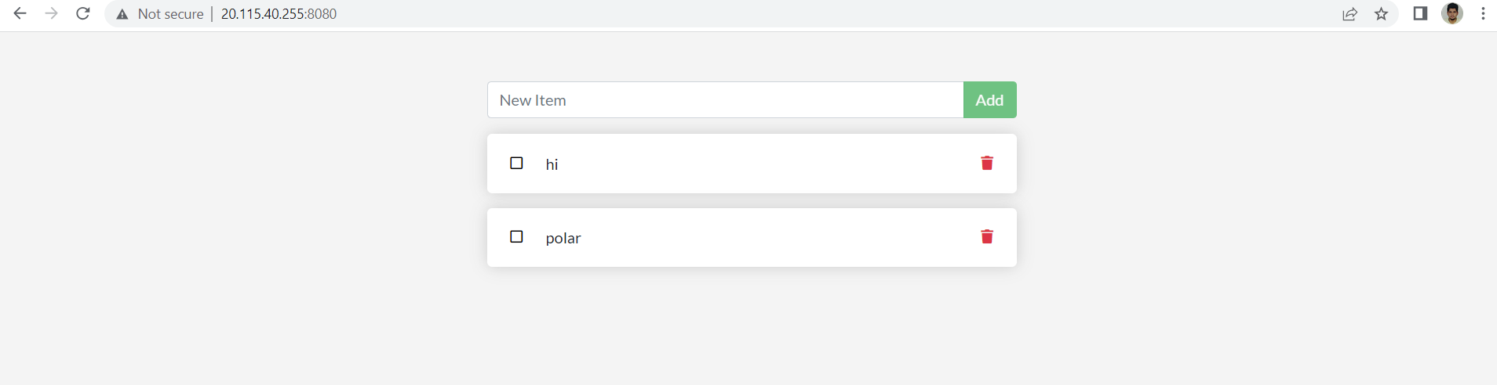

**Figure 3 : todo app**

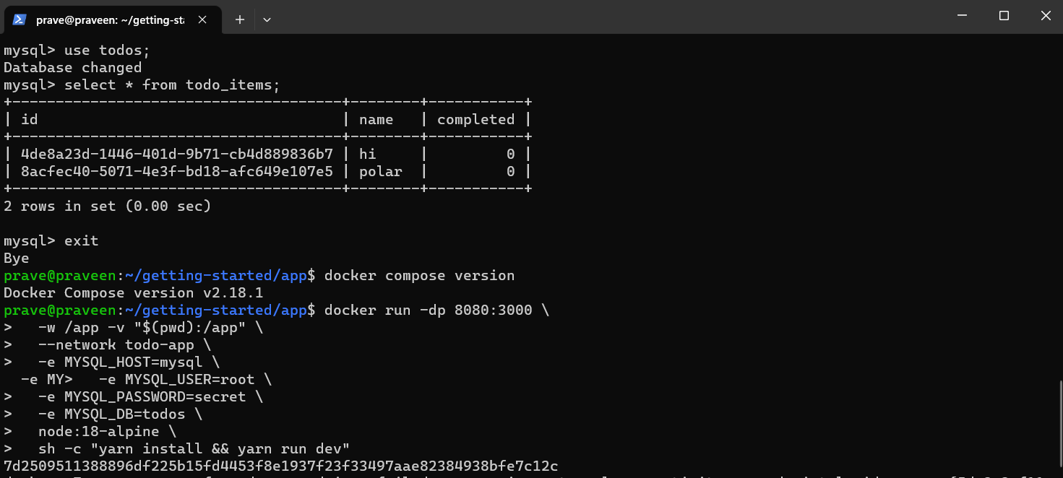

**Figure 4: databases**

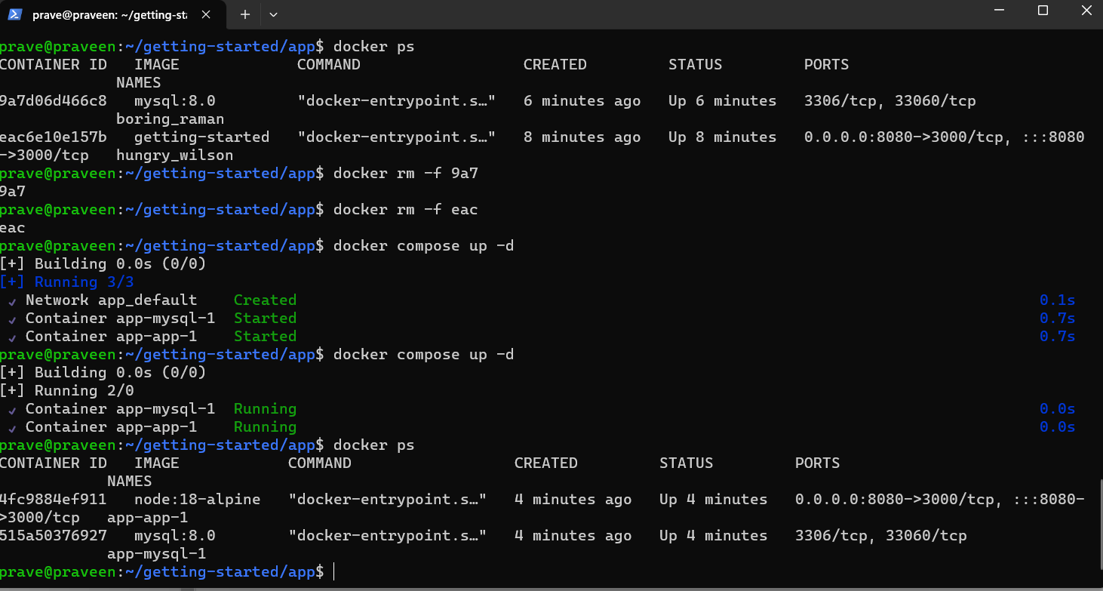

**Figure 5: docker compose**

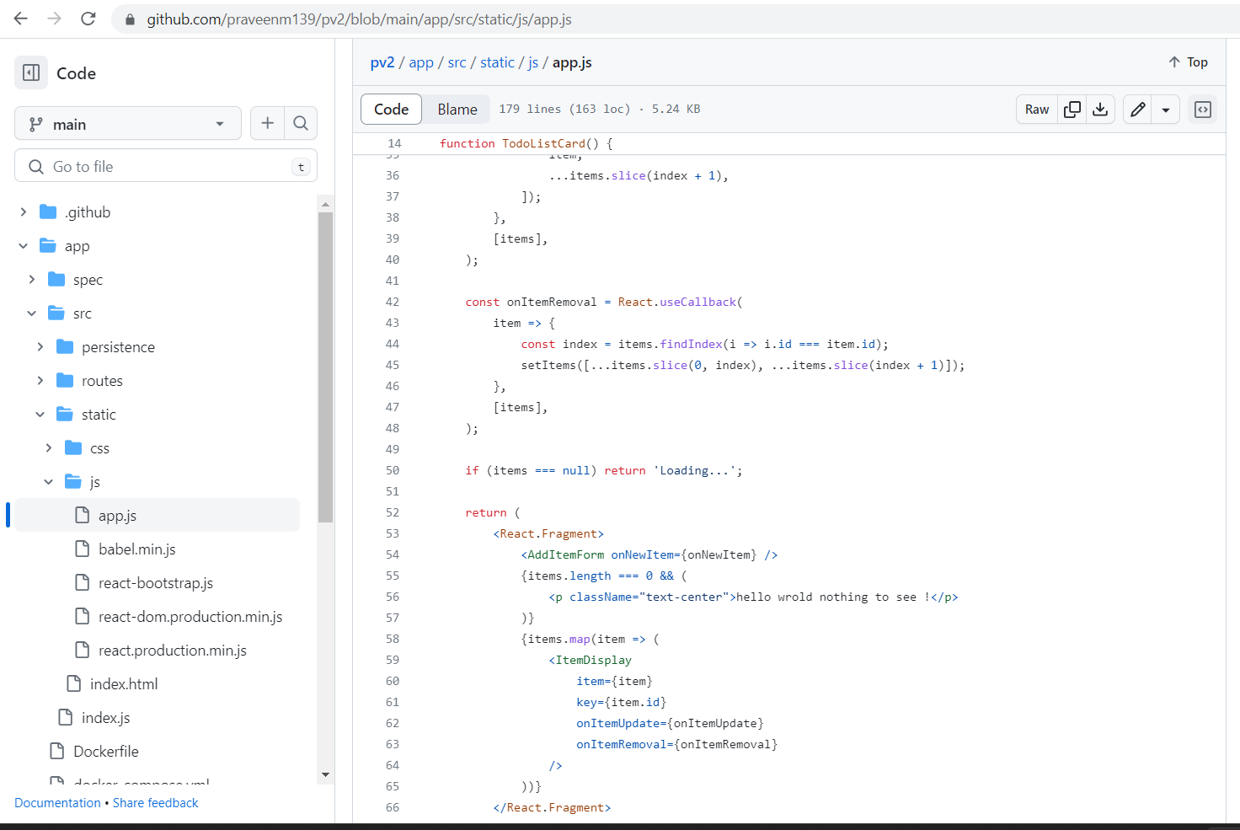p

**Figure 6 : Running App**